**Electronic supplementary information**

**SYNTHESIS OF A CONJUGATE OF CURCUMIN WITH  
A *NIDO*-CARBORANE CLUSTER AND ITS CYTOTOXICITY**

A. A. Druzina,\**a* O. B. Zhidkova,*a* A. A. Antonets,*b* and A. A. Nazarov*b*

a Nesmeyanov Institute of Organoelement Compounds, Russian Academy of Sciences,

ul. Vavilova 28, str. 1, Moscow, 119334 Russia

*b Department of Chemistry, Lomonosov Moscow State University,  
Leninskie Gory 1, str. 3, Moscow, 119991 Russia*

**General** **remarks**

9-N3(CH2)3Me2N-*nido*-7,8-C2B9H11 **1** [S1] and alkynyl curcumin **2** [S2] were synthesized according to the earlier developed procedures. Curcumin (Fisher Scientific, Loughborough, UK), diisopropylethylamine (Carl Roth GmbH, Karlsruhe, Germany) and CuI (PANREAC QUIMICA SA, Barcelona, Spain) were used without further purification. Ethanol, CH3CN and CH2Cl2 were commercial reagents of analytical grade. The reaction progress was monitored by thin-layer chromatography (Merck F245 silica gel on aluminum plates) and visualized using 0.1% PdCl2 in 3 M HCl. Acros Organics silica gel (0.060–0.200 mm) was used for column chromatography. The NMR spectra at 400.1 MHz (1H), 128.4 MHz (11B, 11B{1H}) and 100.0 MHz (13C{1H}) were recorded with a Bruker Avance-400 spectrometer. The residual signal of the NMR solvent relative to Me4Si was taken as the internal reference for the 1H and 13C NMR spectra. The 11B-NMR spectra were referenced using BF3·Et2O as an external standard. The infrared spectra were recorded on a Spectra SF 2000 instrument. The high resolution mass spectra (HRMS) were measured on a micrOTOF II instrument using electrospray ionization (ESI). The measurements were conducted in a positive ion mode (interface capillary voltage –4500 V), with a mass range from *m/z* 50 to *m/z* 3000; external or internal calibration was performed with the ESI Tuning Mix, produced by Agilent. A syringe injection was used for the addition of the solutions to acetonitrile (flow rate 3 µL/min). Nitrogen was applied as a dry gas; the interface temperature was set at 180 °C.

**Experimental procedure and spectral characteristics of compound 3**

**General procedure for the synthesis of 9-[(H(CH2[COCH=CH(OCH3)C6H3O]2))-CH2-С-CH-N3(CH2)3Me2N-*nido*-7,8-C2B9H11 (3)**.A mixture of 9-N3(CH2)3Me2N-*nido*-7,8-C2B9H11 **1** (0.150 g, 0.58 mmol), alkynylcurcumin **2** (0.23 g, 0.58 mmol), diisopropylethylamine (1 mL, 0.74 g, 5.73 mmol), and CuI (0.002 g, 0.03 mmol) in 20 mL of ethanol was refluxed for 7 h. The resulting mixture was cooled to room temperature and passed through *ca.* 2–3 cm of silica gel on a Schott filter. The solvent was removed under vacuum. The crude product was purified by silica gel column chromatography using CH2Cl2–MeCN as an eluent to give the target product as a white solid. Yield: 0.28 g (73%). 1H NMR (400 MHz, acetone-*d*6): *δ* 8.18 (1H, s, CC*H*N3), 7.63 (2H, d, 2×C*H*=CH, *J* = 16.0), 7.36 (2H, s, 2×C*HAr*), 7.22 (3H, m, С*H*=CH, 2×C*HAr*), 6.90 (1H, d, С*H*=CH, *J* = 16.0), 6.76 (2H, m, 2×C*HAr*), 6.01 (1H, s, С*Н*), 5.27 (2H, s, -C*H2*-CCHN3), 4.67 (2H, m, CCHN3-C*H2*), 3.94 (3H, s, OС*Н3*), 3.90 (3H, s, OС*Н3*), 3.56 (2H, m, C*H2*NMe2), 3.08 (3H, s, N*Me*2), 3.06 (3H, s, N*Me*2), 2.65 (3H, m, C*H2*, C*H*carb), 1.87 (1H, m, C*H*carb), –3.43 (1H, br. s., *Hextra*) ppm. 11B NMR (128 MHz, аcetone-*d*6): *δ* 5.5 (1B, s), –5.5 (1B, d, *J* = 141), –17.2 (2B, d, *J* = 180), –19.5 (1B, d, *J* = 120), –25.0 (1B, d, *J* = 149), –26.7 (1B, d, *J* = 142), –32.1 (1B, d, *J* = 166), –38.7 (1B, d, *J* = 144) ppm. 13C NMR (101 MHz, аcetone-*d*6): *δ* 183.4 (*С*=О), 183.2 (*С*=О), 150.1 (O*CAr*), 150.0 (O*CAr*), 149.2 (*C*CHN3), 147.9 (*CAr*), 143.4 (*CAr*), 140.7 (*CAr*), 140.0 (*CAr*), 128.7 (СH=*C*H), 127.2 (*C*H*Ar*), 124.2 (*C*H*Ar*), 123.0 (*C*H*Ar*), 122.4 (*С*H=CH) , 122.3 (*CAr*), 121.4 (C*CH*N3), 115.4 (*C*H*Ar*), 113.7 (*C*H*Ar*), 110.7 (*С*H=CH), 110.6 (СH=*C*H), 100.9 (CO-*С*H-CO), 64.6 (CCHN3-*C*H2), 62.3 (*C*H2-CCHN3), 55.4 (O*C*H3), 55.3 (O*C*H3), 52.8 (N*Me*2), 51.1 (N*Me*2), 47.2 (*C*H2NMe2), 46.4 (*C*Hcarb), 33.9 (*C*Hcarb), 25.0 (CH2). HRMS (ESI) *m/z:* found 668.4298 [C31H45B9N4O6+H]+; calcd 668.4303. IR (solid, *ν*, cm–1): 2962 (C-H), 2941 (C-H), 2541 (C-H), 2367, 2347, 1628, 1591, 1565, 1508, 1454, 1424, 1267, 1138, 1042, 972.

**Cell cultures and MTT assay**

Human ovarian adenocarcinoma cell line A2780 was obtained from the European Collection of Authenticated Cell Cultures (ECACC, Salisbury, UK). The cells were grown in RPMI-1640 cell medium (Gibco, Ireland) supplemented with 10% fetal bovine serum (FBS, Gibco, Brazil). The cells were cultured in an incubator at 37 °C in a 5% CO2 atmosphere and subcultured twice a week. The antiproliferative activity of the cells was assessed using MTT assays, as previously described [S3].

**References**

S1. A. A. Druzina, O. B. Zhidkova, N. V. Dudarova, I. D. Kosenko, I. V. Ananyev, S. V. Timofeev, V. I. Bregadze, *Molecules*, **2021**, *26*, 530. DOI: 10.3390/molecules26030530

S2. A. Averick, S. Dolai, A. Punia, K. Punia, S. R. Guarigli, W. L'Amoreaux, K.-L. Hong, K. Raja, *React. Funct. Polym*., **2016**, *102*, 47–52. DOI: 10.1016/j.reactfunctpolym.2016.03.009

S3. Y. N. Nosova, L. S. Foteeva, I. V. Zenin, T. I. Fetisov, K. I. Kirsanov, M. G. Yakubovskaya, T. A. Antonenko, V. A. Tafeenko, L. A. Aslanov, A. A. Lobas, M. V. Gorshkov, M. S. Galanski, B. K. Keppler, A. R. Timerbaev, E. R. Milaeva, A. A. Nazarov, *Eur. J. Inorg. Chem*., **2017**, 1785–1791. DOI: 10.1002/ejic.201600857



**Figure S1**. IR spectrum of compound **3.**

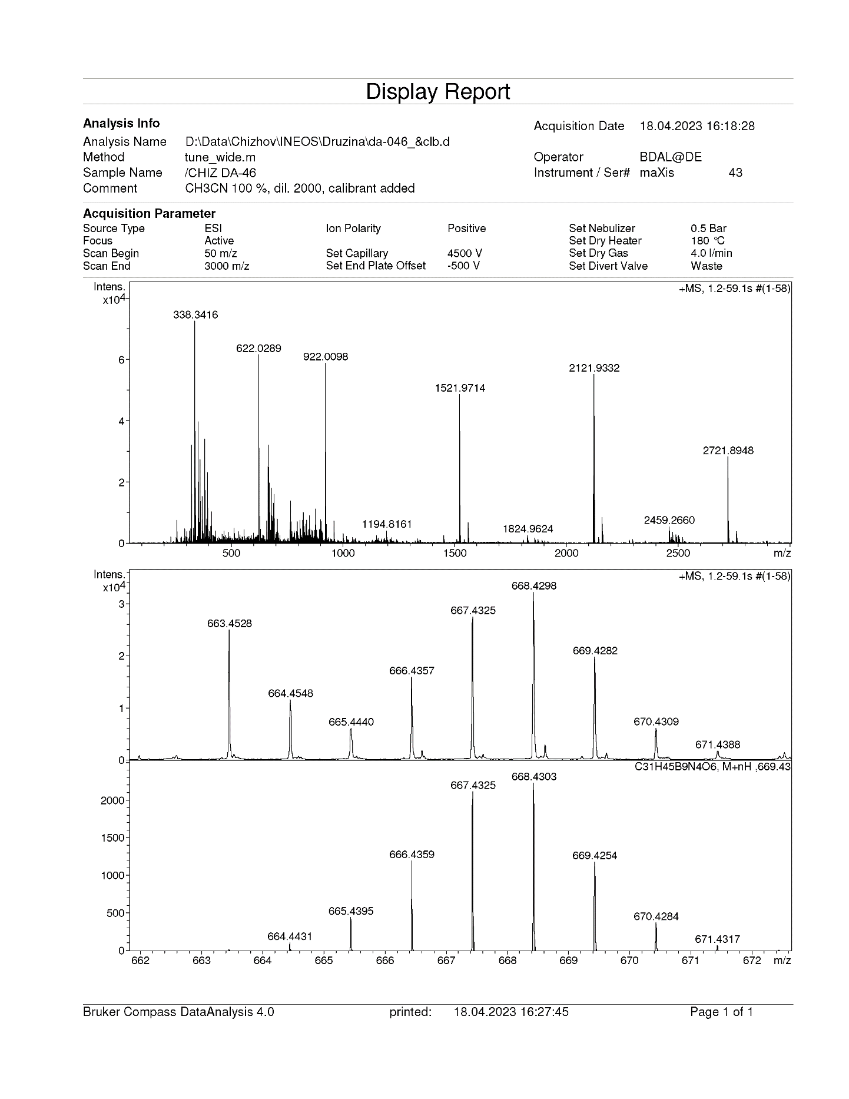

**Figure S2**. ESI-HRMS spectrum of compound **3**.



Compound **3**

1H, acetone-*d6*

**Figure S3**. 1H NMR spectrum of compound **3**.



Compound **3**

13C{1H}, acetone-*d6*

**Figure S4**. 13C{1H} NMR spectrum of compound **3**.



Compound **3**

11B, acetone-*d*6

**Figure S5**. 11B{1H} NMR spectrum of compound **3**.



Compound **3**

11B, acetone-*d*6

**Figure S6**. 11B NMR spectrum of compound **3**.